**PROJECT REPORT**

**TITLE :** Emerging Methods For Early Detection of Forest Fire

**TEAM ID** **:** PNT2022TMID28630

**TEAM MEMBERS** **:**

AARTHY S [410719104001]

ASHA NANDHINI G [410719104007]

J K DEVADHARSHINI [410719104022]

MITTA LAKSHMIGAYATHRI [410719104054]

**DHANALAKSHMI COLLEGE OF ENGINEERING**

**ANNA UNIVERSITY:CHENNAI-600 025**

**NOVEMBER 2022**

**Project Report Format**

1. INTRODUCTION

2. LITERATURE SURVEY

3. IDEATION & PROPOSED SOLUTION

4. REQUIREMENT ANALYSIS

5. PROJECT DESIGN

6. PROJECT PLANNING & SCHEDULING

7. CODING & SOLUTION (Explain the features added in the project along with code)

8. TESTING

9. RESULTS

10.ADVANTAGES & DISADVANTAGES

11. CONCLUSION

12. FUTURE SCOPE

13.APPENDIX

**1.INTRODUCTION**

**1.1 PROJECT OVERVIEW**

Forest fires are occurring throughout the year with an increasing intensity in the summer and autumn periods. These events are mainly caused by the actions of humans, but different nature and environmental phenomena, can also be credited for their occurrence. Regardless of the reasons for the ignition of the forest fires, they usually cause devastating damage to both nature and humans. To fight forest fires, different solutions were employed throughout the years. They were primarily aimed at the early detection of the fires.

The simplest of these solutions is the establishment of a network of observation posts - both cheap and easy to accomplish, but also time-consuming for the involved people. The constant evolution of the information and communication technologies has led to the introduction of a new generation of solutions for early detection and even prevention of forest fires. ICT-based networks of cameras and sensors and even satellite-based solutions were developed and used in the last decades.

These solutions have greatly decreased the direct involvement of humans in the forest fire detection process, but have also proven to be expensive and hard to maintain. In this paper we will discuss and present two different emerging solutions for early detection of forest fires. The solution involves the use of unmanned aerial vehicles (UAVs) with specialized cameras. Several different scenarios for the possible use of the drones for forest fire detection will be presented and analyzed, including a solution with the use of a combination between a fixed-wind and a rotary-wing UAVs.

**1.2 PURPOSE**

One of the major environmental issues (forest fire), creating economic and ecological damage while endangering human lives. There are typically about 100,000 wildfires around the world every year. Over 9 million acres of land have been destroyed due to treacherous wildfires. It is difficult to predict and detect Forest Fire in a sparsely populated forest area and it is more difficult if the prediction is done using ground-based methods like Camera or Video-Based approach. Satellites can be an important source of data prior to and also during the Fire due to its reliability and efficiency. The various real-time forest fire detection and prediction approaches, with the goal of informing the local fire authorities.

**2.LITERATURE SURVEY**

**2.1 Existing Problem**

|  |  |  |  |
| --- | --- | --- | --- |
| **S.NO** | **AUTHOR** | **TITLE** | **NAME OF JOURNAL** |
| 1. | Medi RahuL, Karnekanti Shiva, SakethAttiliSanjeet and Nenavath Srinivas Naik. | Early Detection of Forest fire using Deep Learning. | 2020.IEEE REGION10 Conference(TENCON),2020,pp.  11361140,doi:10.1109/tencon  50793.2020.9293722. |

* The system involves pre-processing the image data and applying data augmentation such as shearing, flipping, etc.
* It uses models like VGG16 , ResNet50 , and DenseNet121 for the classification of images.
* The model initially divides the train and test sets in 80% and 20% and then sent to the pre-processing phase, where finally it is trained to classify them into two classes fire and non-fire.
* By using the optimal learning rate the proposed model was able to achieve a training set accuracy of 92.7% and an est set accuracy of 82.57%.

|  |  |  |  |
| --- | --- | --- | --- |
| **S.NO** | **AUTHOR** | **TITLE** | **NAME OF JOURNAL** |
| 2. | Byron Arteaga, Mauricio Diaz, Mario jajoa, University of Naino Pasto Columbia . | Deep Learning  Applied forest  Fire Detection. | 2020 IEEE International Symposium on signal processing and information Technology(ISSPIT),2020,pp,  16,doi:10,1109/ISSPIT51521.2020.9408859. |

* The data processing was done through open source programming language Python, the cloud service Googlecollab, and deep learning algorithms using Pytorch's library.
* After the data augmentation and pre-processingof the training image, three types of transformation takes place cropping of the image, rotating of an image, and normalizing of the image.
* The classification of images is done by using the pre-trained models of ResNet and VGG pre-trained models.
* To validate the performance of each pre-trained model the k-fold method is used.
* The model obtained during the validationis sent to Raspberry to test its functionality.

|  |  |  |  |
| --- | --- | --- | --- |
| **S.NO** | **AUTHOR** | **TITLE** | **NAME OF JOURNAL** |
| 3. | Raghad k. Mohammed(Department of Basic sciences,college of Density, University Baghdad,Baghdad,Iraq). | A Real-time forest fire and  Smoke detection  System Using  Deep Learning. | International Journal of Nonlinear Analysis and Application 13.1(2022):2053-  2063. |

* The proposed framework aims to detect smoke and fire based on the images received from the video stream from the Raspberry Pi
* Pre-processing of image data.
* Image data augmentation (Scale, horizontal flip, and vertical flip).
* Pre-trainingng model imagenet dataset ->{inception-ResNet-V2}.
* By fine-tuning the above two steps we have to send that to the fully connected layer with softmax.
* we can view the model accuracy as instead.

|  |  |  |  |
| --- | --- | --- | --- |
| **S.NO** | **AUTHOR** | **TITLE** | **NAME OF JOURNAL** |
| 4. | Suhas.G ,Chetan Kumar,Abhishek.B.S, Digvijay Gowda.K.A, Prajwal.R . student of Department of Computer Science and Engineering, Maharaja Institute of Technology Mysore, Karnataka, India | Fire Detection Using Deep  Learning. | International Journal of Progressive Research in Science And Engineering Volume-1, Issue-5,August-2020. |

* The model is divided into two parts
* a. Data collection and Pre-processing.
* b. Building fire detection model by transfer learning.
* The first step is to gather video frames and it should be divided into two classes fire and non-fire. The collected dataset is divided into train and test sets.
* The second step is to extract the video features of pre-trained models using Keras.
* We have used ResNet-50, Inception V3, and InceptionResNetV2 models to extract the features and various ML algorithms on the extracted features to detect fire in video frames.

**2.2 References**

Early Detection of Forest Fire Based on Unmanned Aerial Vehicle Platform (Published on 2019 IEEE),

[1]Official webpage of the European Forest Fire Information System at:

http://effis.jrc.ec.europa.eu/

[2]Official webpage of the Copernicus Earth Observation Programme at: <http://www.copernicus.eu>

[3] The 2018 Attica wildfires Wikipedia webpage available at:

https://en.wikipedia.org/wiki/2018_Attica_wildfires

[4] László Földi and Rajmund Kuti, Characteristics of Forest Fires and

their Impact on the Environment, Academic and Applied Research in

Military and Public Management Science (AARMS), Vol. 15, No. 1,

2016, pp. 5–17, ISSN 2064-0021; https://www.firedex.com

[6] Wolfgang Jendsch, Aerial Firefighting, Schiffer Publishing, 352 pp,

ISBN 9780764330681

[7] Chi Yuan, Youmin Zhang and Zhixiang Liu, A Survey on Technologies for Automatic Forest Fire Monitoring, Detection and Fighting Using UAVs and Remote Sensing Techniques, Canadian Journal of Forest Research.

[8] W. Krüll, R. Tobera, I. Willms, H. Essen and N. V. Wahl, Early Forest

Fire Detection and Verification Using Optical Smoke, Gas and

Microwave Sensors, Procedia Engineering vol. 45, pp. 584-594, 2012

[9] Project SFEDA page at: http://www.interreg-balkanmed.eu/approved-

project/22/

[10] Image Processing for Forest Fire Detection (Published on January 2016 ), and

Early Fire Detection In Forest Using Wireless Sensor Networks (Published on MARCH 2020)

**2.3. Problem Statement Definition**

In earlier times fires were detected with the help of watching towers or using satellite images. Satellites collect images and send it to the monitoring authority which will decide by seeing images that it is a fire or not. But this approach was very slow as the fire may have spread in the large areas and caused so much damage before the rescue team came. In the watching tower method, a person always stands on the tower, who usually monitors the area and informs if there was fire. This method was also slow because before the man got to know about the fire it may have spread in the inner parts of forest, also it always requires a man who must be present there. Since, we know that some areas, especially forest areas are large so it is practically impossible to put a man in every part of forest from where they can monitor the forest area.So, both these approaches of watching towers and satellite images failed to detect fire as early as possible to reduce the damage done by fire Problems in fire detection.There were mainly two problems in fire detection as discussed:

(a). **Judging criteria for the fire**: Edge is set, on the off chance that the worth is more noteworthy than edge, it is a fire, else not. So, this problem was removed by using machine learning techniques by many researchers.

(b). **Connection of nodes:** Traditional systems used cables to connect alarm with the detectors. Cable was mainly of copper. But copper wire may be costly or it can suffer from fault in the mid-way. So, this problem was removed using wireless sensor networks.

So, with the advancement in technology researchers find an efficient method to detect forest fire with the help of Wireless Sensor Network. Fire can be identified by conveying sensor hubs in timberland regions by which they illuminate about fire. Conveying sensor hubs in the timberland regions means placing sensors in every part of the forest and mostly in the prone areas where risk of 9 catching fire is more. With the use of wireless sensor networks, now it is easy to detect the fire in large areas as soon as possible.

**3. IDEATION AND PROPOSED SOLUTION**

**3.1 Empathy Map Canvas**

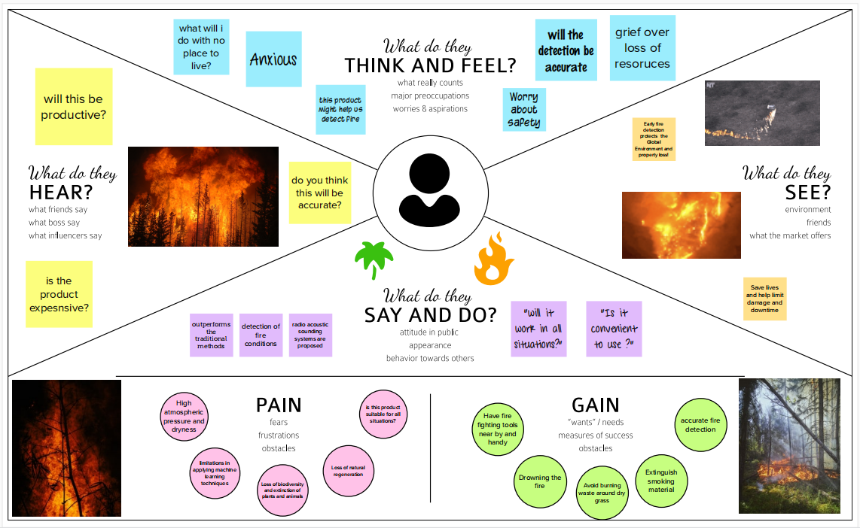

**3.2 Ideation & Brainstorming**

**Step-1**: Team Gathering, Collaboration and Select the Problem Statement



**Step-2**: Brainstorm, Idea Listing and Grouping

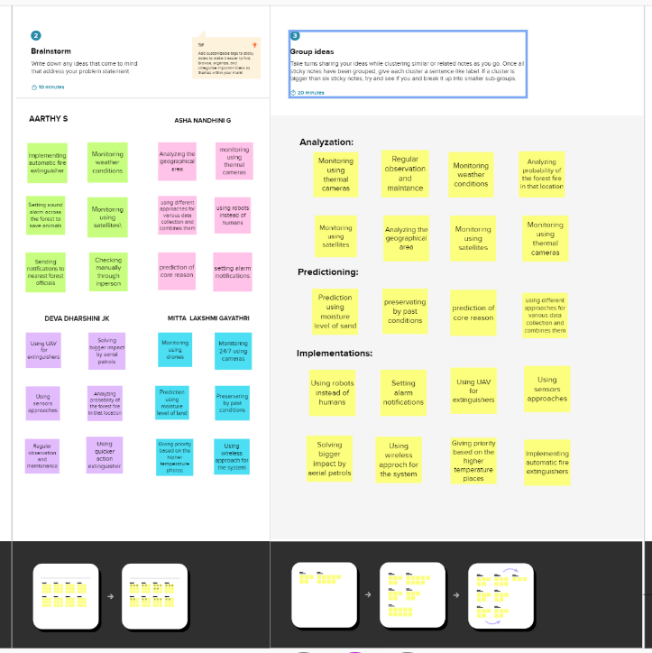

**Step-3**: Idea Prioritization

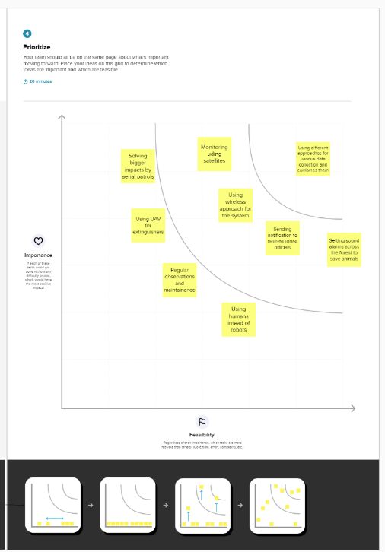

**3.3 . Proposed Solution**

| **S.No.** | **Parameters** | **Description** |
| --- | --- | --- |
| 1. | **Problem Statement**  **(problem to be solved)** | AI based Emerging methods for early detection of forest fires. |
| 2. | **Idea / Solution description** | A solution is needed which detects the smoke and gasses released by the wildfire.This solution must buy time for firefighters to put down the fire before it goes out of control. |
| 3. | **Novelty / Uniqueness** | Remote sensing machine learning wildfire prediction data mining using artificial intelligence. |
| 4. | **Social Impact / Customer Satisfaction** | The main factors to be considered are the possible earliest detection of wildfire and also the specific type of fire. |
| 5. | **Business Model (Revenue Model)** | This application will be available in a subscription-based model. Supply chain, power & supply, Fire stations, and government by providing services. |
| 6. | **Scalability of the Solution** | This application can monitor different places simultaneously and can detect fire accurately. It can handle a large number of users and data simultaneously. |

**3.4 PROBLEM SOLUTION FIT**

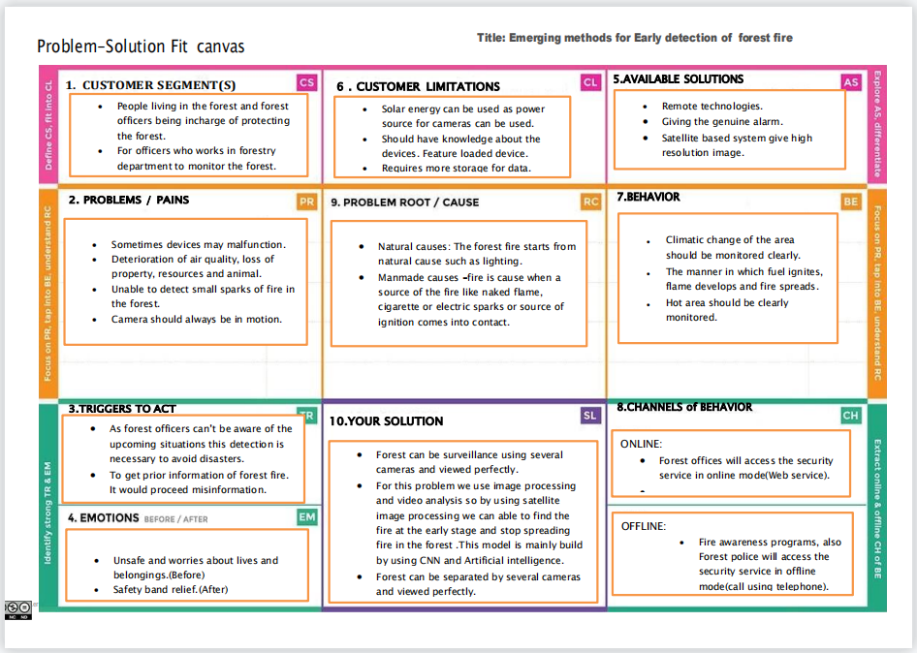

**4.REQUIREMENT ANALYSYIS**

**4.1 FUNCTIONAL REQUIREMENTS**

Following are the functional requirements of proposed solution

**1.High Priority :**

* The system shall take training sets of fire images and recognize whether there is a fire or smoke or if there is no fire. The system shall send a notification to the admin when it recognizes a fire in the given image.
* Real images are given as input to the system (i.e camera) and output is determined as whether the image contains fire or not.
* The system shall be able to take images with a variety of sizes and convert it to one fixed image to be used throughout the application.The system shall run as a service on either a Windows or Linux operating system.
* In the event that the computer on which the system is running shuts down, the system service should start automatically when the computer restarts.

**2.Medium Priority :**

* The system shall provide the following facility that will allow web pages that the user is permitted to access. The system must support the following facility:

a. Send alert message

b. Customer data management

**3.Low Priority :**

* The system shall allow the user's status to be stored for the next time he returns to the web site.This will save the user x minutes per visit by not having to re-enter the data.
* The system shall provide information about the event log of forest.

**4.2 NON-FUNCTIONAL REQUIREMENTS**

**Non-Functional Objectives**

* Reliability

The system shall be completely operational at least x% of the time. Down time after a failure shall not exceed x hours.

* Usability

Customer Should be able to use the system in his job for x days. A user who already knows what camera he is using should be able to connect and view that page in x seconds.

* Performance

The system should be able to support x simultaneous users. The mean time to view a web page over a 56Kbps modem connection shall not exceed x seconds..

* Security

The system shall provide password protected access to web pages that are to be viewed only by users.

* Supportability

The system should be able to accommodate many camera links. The system web site shall be viewable from chrome or any browser.

* Interfaces

The system must interface with the cloudant db for customer and customer log information, the acquired web site search engine.

**5. PROJECT DESIGN**

**5.1 Data Flow Diagrams :**

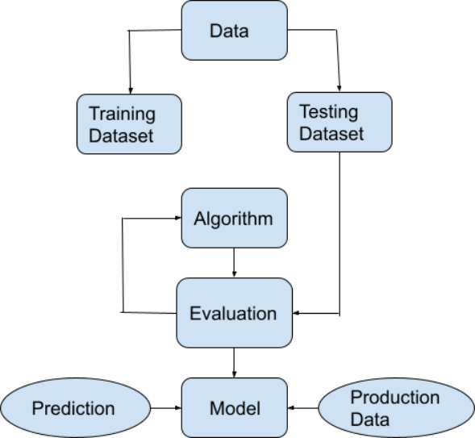

**5.2 Solution & Technical Architecture :**

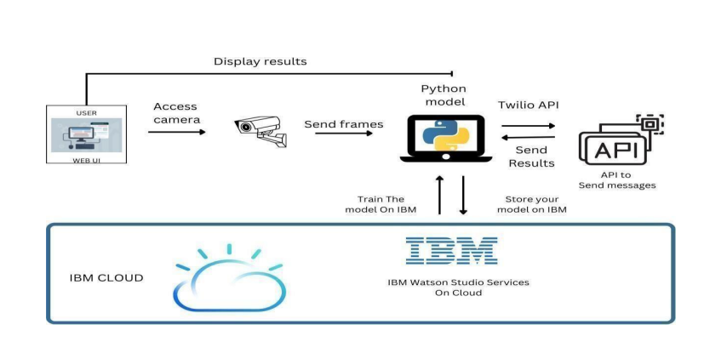

**5.3 User Stories :**

| **User Type** | **Functional Requirement(Epic)** | **User Story Number** | **User Story / Task** | **Acceptance Criteria** |
| --- | --- | --- | --- | --- |
| Customer(Mobile user,Web user) | Video Surveillance | USN-1 | Surveillance is done through remote control | UAVs are used for the surveillance of the forest |
|  | Monitoring of Forest | USN-2 | Forest is continuously monitored through cameras | The Camera catches all and any unusual image of the forest |
|  | Detection of Fire | USN-3 | Using CNN models Fire is detected | CNN models are used to detect flames on the forest surface |
|  | Alert | USN-4 | First responders are alerted through messages and an alarm | Incase of a detected flame, the first responders are alerted and a loud alarm starts blaring |

**6. PROJECT PLANNING AND SCHEDULING**

**6.1 Sprint Planning & Estimation:**

| **Sprint** | **Functional Requirement (epic)** | **User Story Number** | **User Story / Task** | **Story Points** | **Priority** | **Team Members** |
| --- | --- | --- | --- | --- | --- | --- |
| sprint-1 | Image Processing | USN-1 | Processing the image to find the fire is detected or not. | 1 | Medium | 1. Aarthy S  2. Asha Nandhini G  3. J K Devadharshini  4. Mitta Lakshmi Gayathri |
| sprint-2 | Video Processing | USN-2 | The drone videos will be split into frames to detect the fire. | 3 | High | 1. Aarthy S  2. Asha Nandhini G  3. J K Devadharshini  4. Mitta Lakshmi Gayathri |
| sprint-3 | Alerting | USN-3 | After the fire is detected the alert message has to be sent. | 2 | High | 1. Aarthy S  2. Asha Nandhini G  3. J K Devadarshini  4. Mitta Lakshmi Gayathri |
| sprint-4 | Location Tracking | USN-4 | The exact location of the drone will be predicted and sent along with the alert message | 2 | High | 1. Aarthy S  2. Asha Nandhini G  3. J K Devadharshini  4. Mitta Lakshmi Gayathri |

**6.2 Sprint Delivery Schedule :**

| **Sprint** | **Total Story Points** | **Duration** | **Sprint Start Date** | **Sprint End Date (Planned)** | **Story Points Completed (as on planned end date)** | **Sprint Release Date (actual)** |
| --- | --- | --- | --- | --- | --- | --- |
| Sprint-1 | 20 | 3 Days | 27 Oct 2022 | 29 Oct 2022 | 20 | 29 Oct 2022 |
| Sprint-2 | 20 | 3 Days | 30 Oct 2022 | 1 Nov 2022 | 20 | 1 Nov 2022 |
| Sprint-3 | 20 | 3 Days | 3 Nov 2022 | 5 Nov 2022 | 20 | 5 Nov 2022 |
| Sprint-4 | 20 | 3 Days | 7 Nov 2022 | 9 Nov 2022 | 20 | 9 Nov 2022 |

**6.3 Report**

**Burndown Chart :**

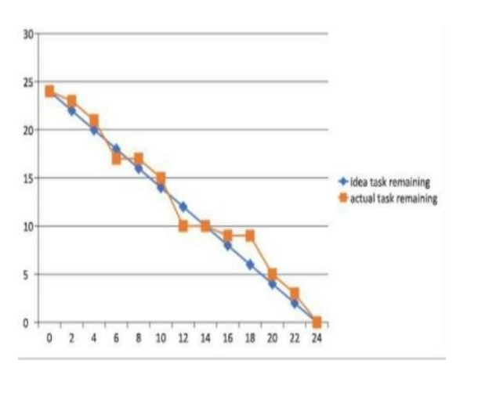

**7.CODING AND SOLUTION**

**Code:**

**1) home.html :**

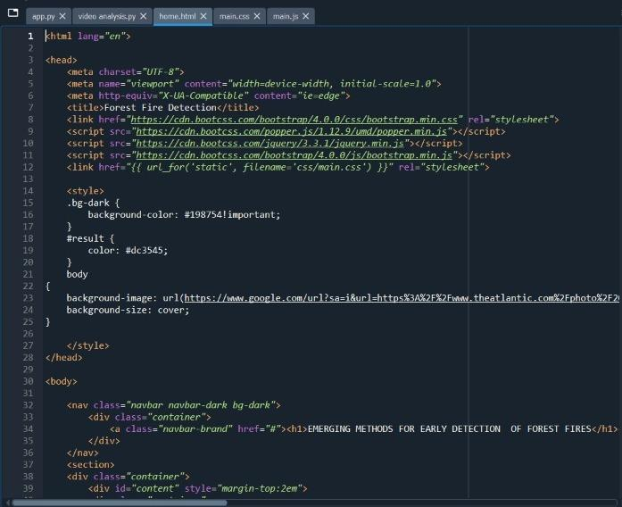

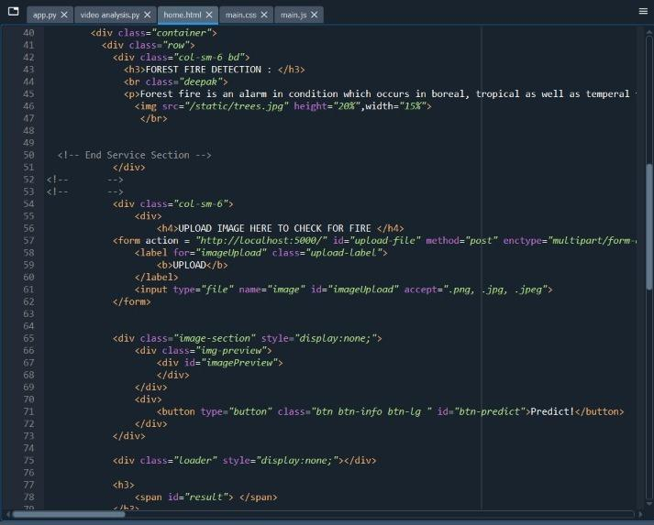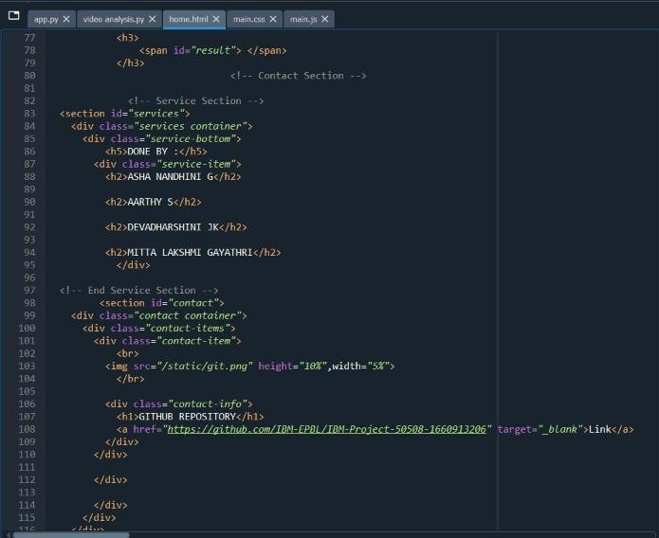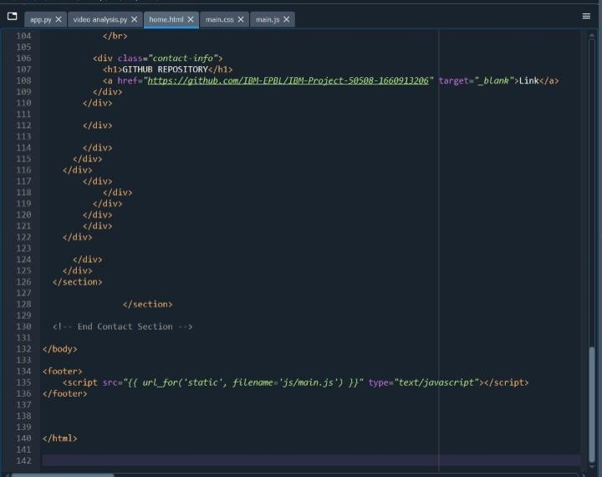

**Code:**

**1. Main.css :**

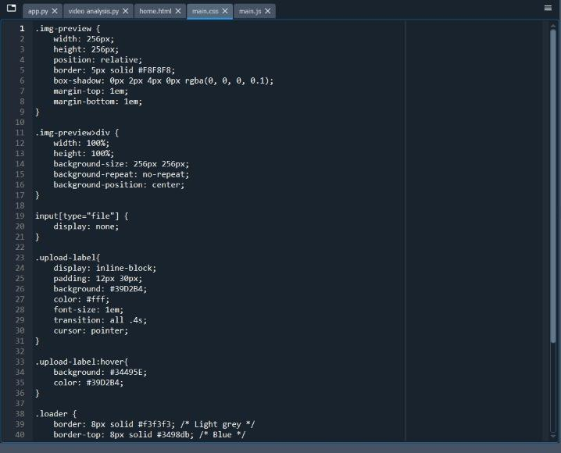

**Main.js :**

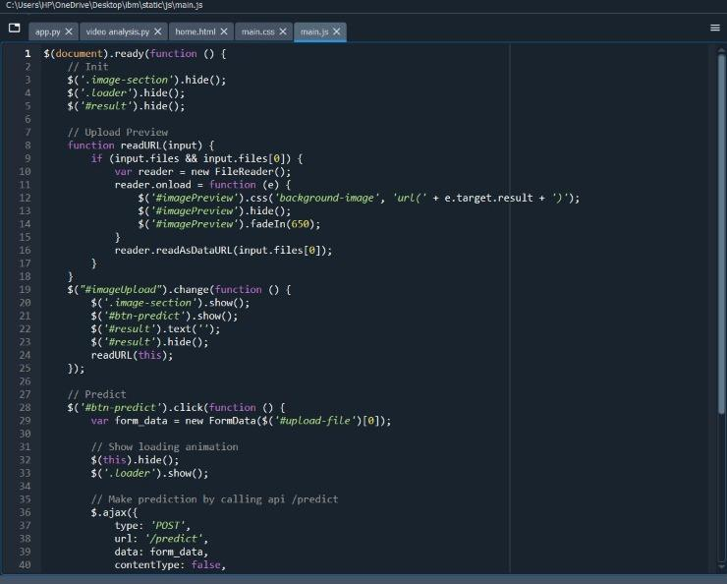

**Video analysis :**

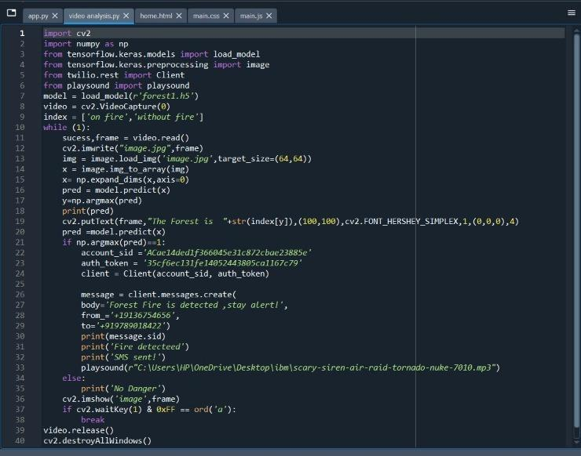

**App.py :**

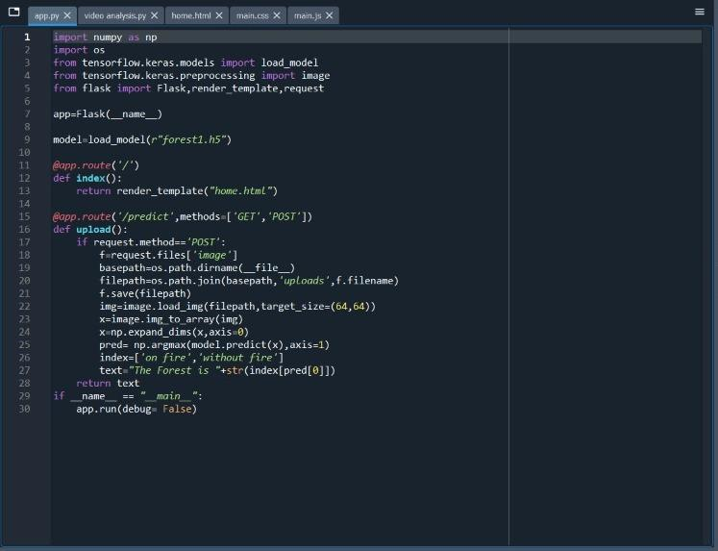

**8.TESTING**

**8.1. User Acceptance Testing:**

**Purpose of Document:**

The purpose of this document is to briefly explain the test coverage and open issues of the [Early detection of forest fire using Deep Learning] project at the time of the release to User Acceptance Testing (UAT).

**Defect Analysis:**

This report shows the number of resolved or closed bugs at each severity level, and how they were resolved.

| **Resolution** | **Severity 1** | **Severity2** | **Severity3** | **Severity4** | **Subtotal** |
| --- | --- | --- | --- | --- | --- |
| By Design | 5 | 1 | 1 | 1 | 8 |
| Duplicate | 1 | 0 | 3 | 0 | 4 |
| External | 2 | 3 | 0 | 1 | 6 |
| Fixed | 7 | 2 | 4 | 10 | 23 |
| Not Reproduced | 0 | 0 | 0 | 0 | 0 |
| Skipped | 0 | 0 | 1 | 1 | 2 |
| Won’t Fix | 0 | 3 | 2 | 1 | 6 |
| Total | 15 | 9 | 11 | 14 | 49 |

**Test Case Analysis:**

This report shows the number of test cases that have passed, failed, and untested

| **Section** | **Total Cases** | **Not Tested** | **Fail** | **Pass** |
| --- | --- | --- | --- | --- |
| Print Engine | 5 | 0 | 0 | 5 |
| Client Application | 30 | 0 | 0 | 30 |
| Security | 2 | 0 | 0 | 2 |
| Out source Shipping | 3 | 0 | 0 | 3 |
| Exception Reporting | 9 | 0 | 0 | 9 |
| Final Report Output | 4 | 0 | 0 | 4 |
| Version Control | 2 | 0 | 0 | 2 |

**9.RESULTS**

**9.1. PERFORMANCE METRICS:**

| **S.No.** | **Parameter** | **Values** |
| --- | --- | --- |
| 1. | Model Summary | As a threat of forest fire increases due to climate changes, the need for finding a detection system increase .  We proposed a Deep Learning-based model for early detection of forest fire. The Proposed model successfully classifies the images into fire and no fire, and sends an alert messages in case of fire. Thus, the Deep Learning algorithms proved their efficiency in detecting different objects. |
| 2. | Accuracy | Training Accuracy - 92% - 98%  Validation Accuracy - 95% |

**10. ADVANTAGES & DISADVANTAGES**

**ADVANTAGES:**

1.Ability to cover areas at different altitudes and locations.

2.The results is quite accurate with the accuracy up to 92%

3.Reliability - The model is very effective, inexpensive and easy to apply.

4.The model, it shows the 'fire' and 'no fire' images classified with high accuracy.

5.Video analysis of this model leads to low degree of misjudgment of fire detection.

**DISADVANTAGES:**

1.Individual learner is responsible for learning global information to avoid false positives.

2.The limited learning and perception ability of individual learners is not sufficient to make them perform well in complex tasks.

3.Proper connectivity and maintenance will be a complex task.

**11.CONCLUSION**

As a threat of forest fire increases due to climate changes, the need for finding a detection system increase .We proposed a Deep Learning-based model for early detection of forest fire. The Proposed model successfully classifies the images into fire and no fire, and sends an alert message in case of fire. Thus, the Deep Learning algorithms proved their efficiency in detecting different objects.

**12.FUTURE SCOPE**

* Integrate live satellite data and process real time processing of the fires.
* Enhance the time complexity of the detection of forest fires to improve the speed.
* These accidents can be controlled to a greater extend.
* Forest fire leads to destruction of excess of species, by using this technique we can save the life and environment.

**13.APPENDIX**

**SOURCE CODE:**

Our GitHub link **-** [**https://github.com/IBM-EPBL/IBM-Project-50508-1660913206**](https://github.com/IBM-EPBL/IBM-Project-50508-1660913206)

Demo Link - <https://youtu.be/I1_Jqh-65wc>